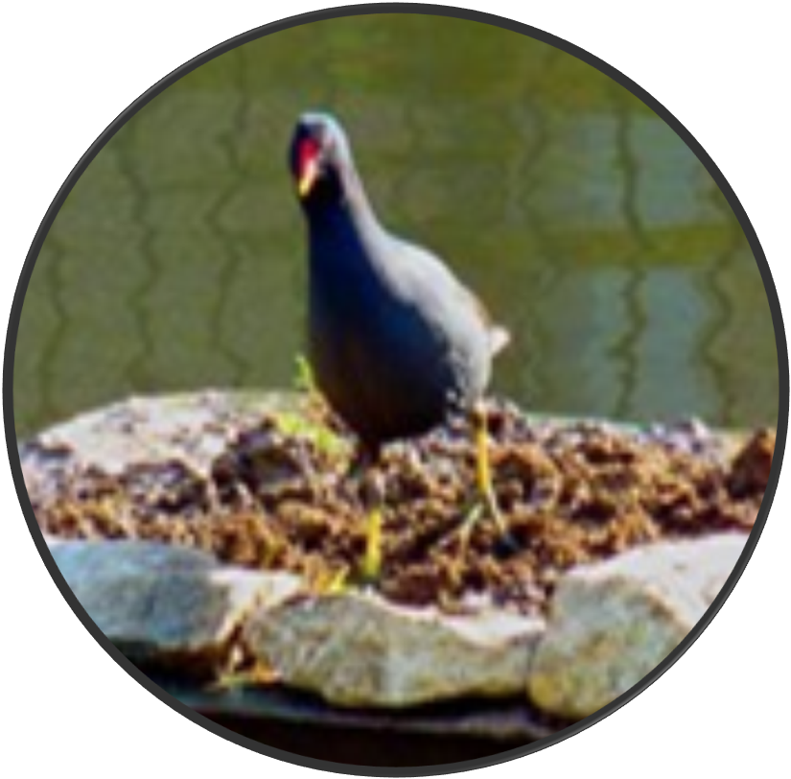

F R I E N D S O F C O N W A Y R E C
Annual General Meeting: Monday 12 February 2024

Clubhouse from 19.15 for hot drinks: meeting starts at 19.30

1. Welcome and apologies for absence

2. Minutes of 21 November Open Meeting

3. Annual Reports:
(a) Treasurer
(b) Chair

4. Election of Officers and Committee:
(a) Chair
(b) Treasurer
(c) Secretary
(d) Members/Roles

5. Targets for the Year Ahead

6 Any Other Business and Date of Next Open Meeting

